Lesson 12 Teacher Reference

Setup for Collision Carts Demonstration

- Add textbooks or binders to elevate one end of the flooring strip 8”-12” to create a ramp. | 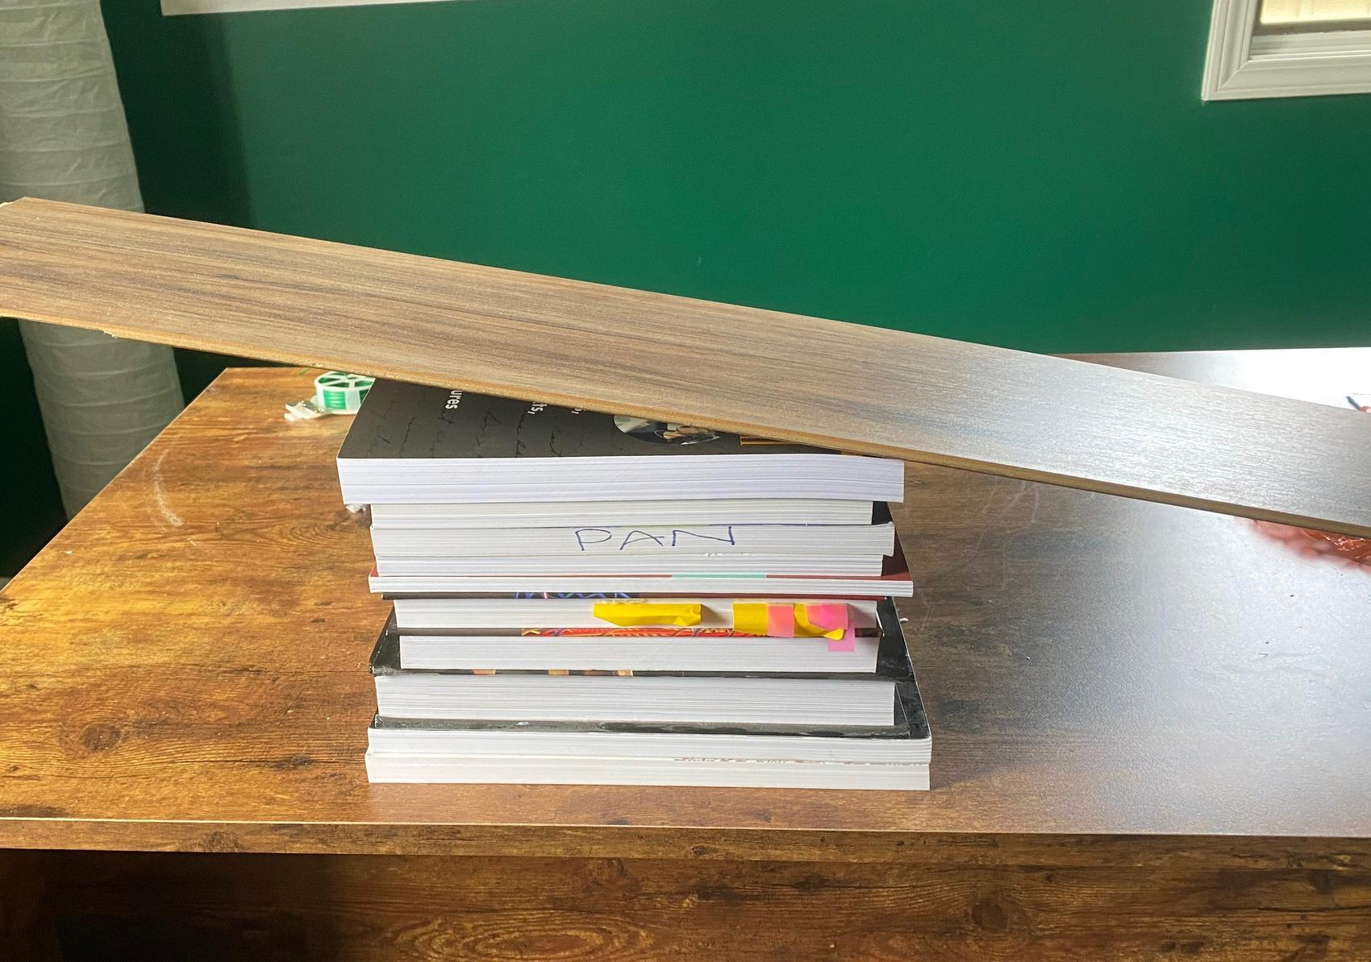
- Angle the lower end of the vinyl flooring strip into the brick. | 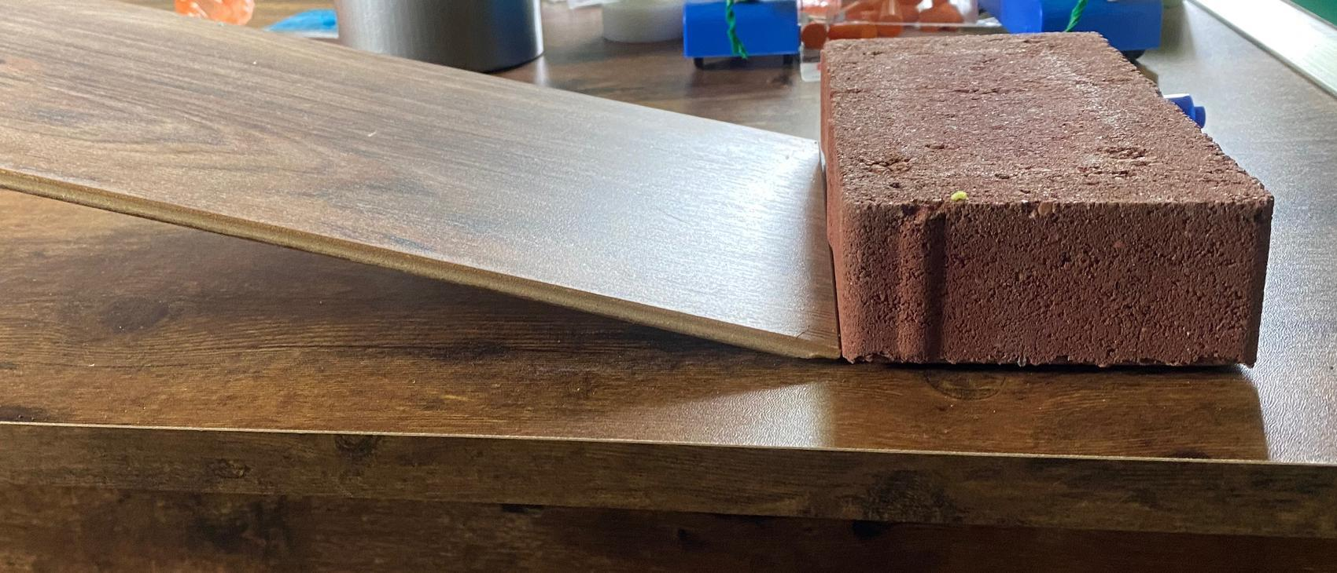
- Place the metal track on the vinyl flooring strip and with its lower end against the brick.  - Place the push-pull spring scales on the carts using the hook and loop fasteners.
  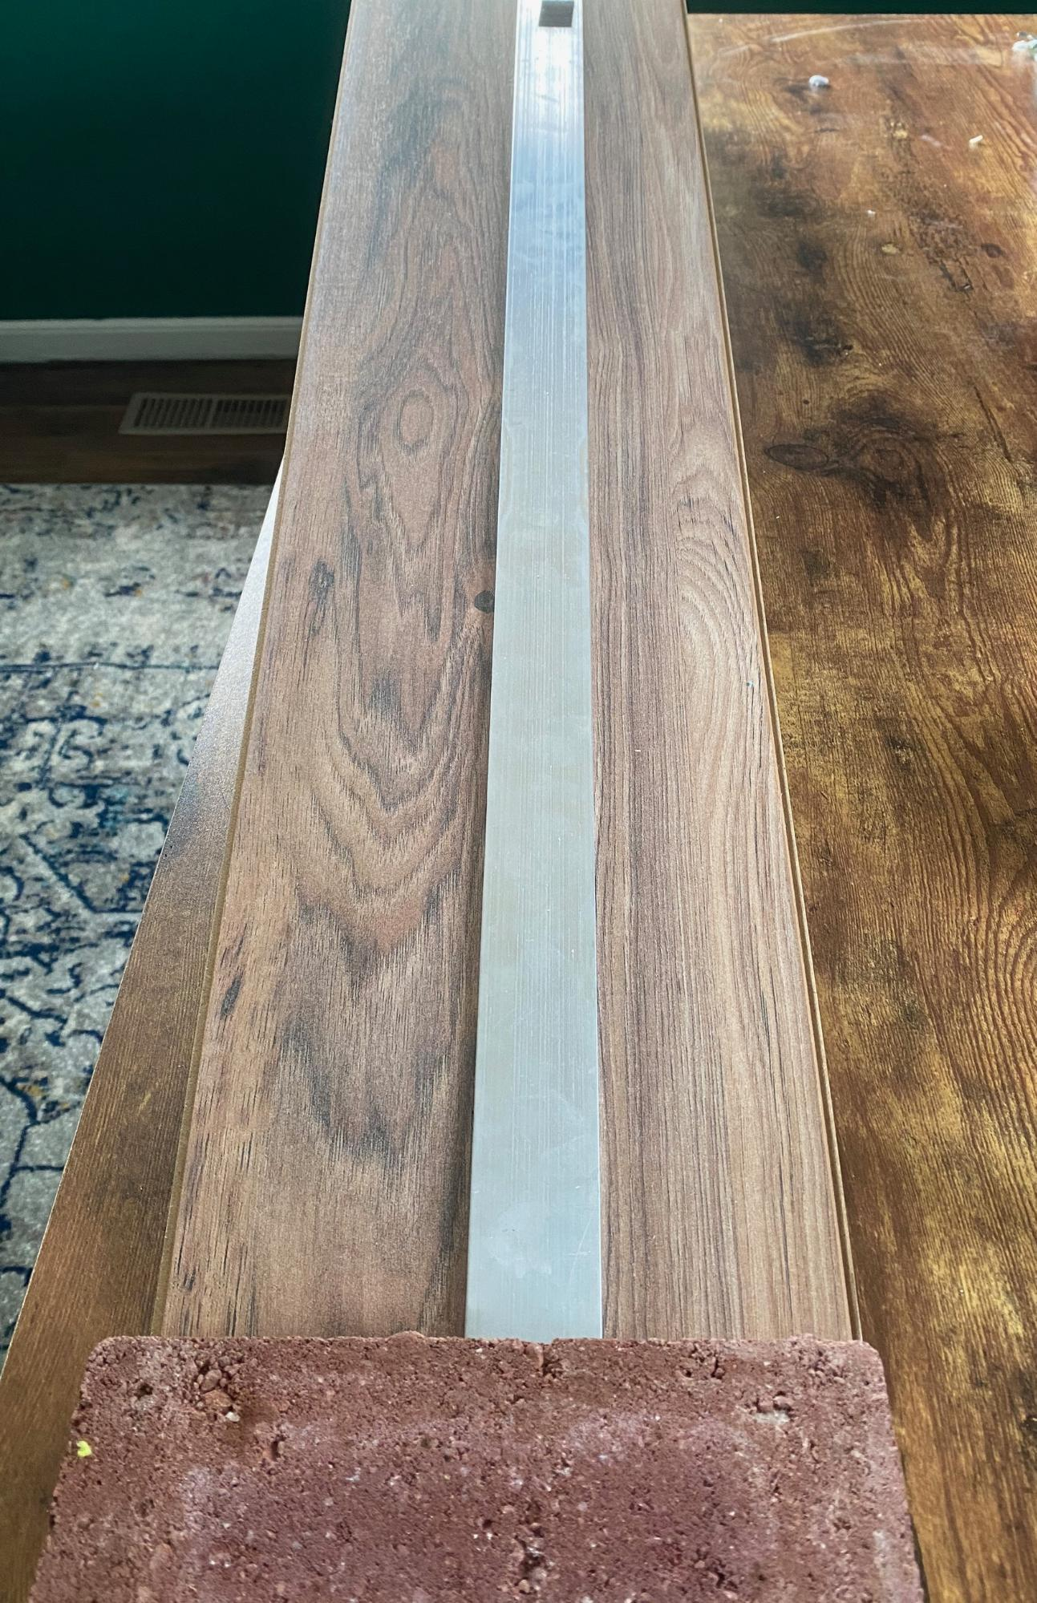
- Mount a plastic, blank electrical plate on the end of the rod on each of the 2 push-pull spring scales using sticky tack. | 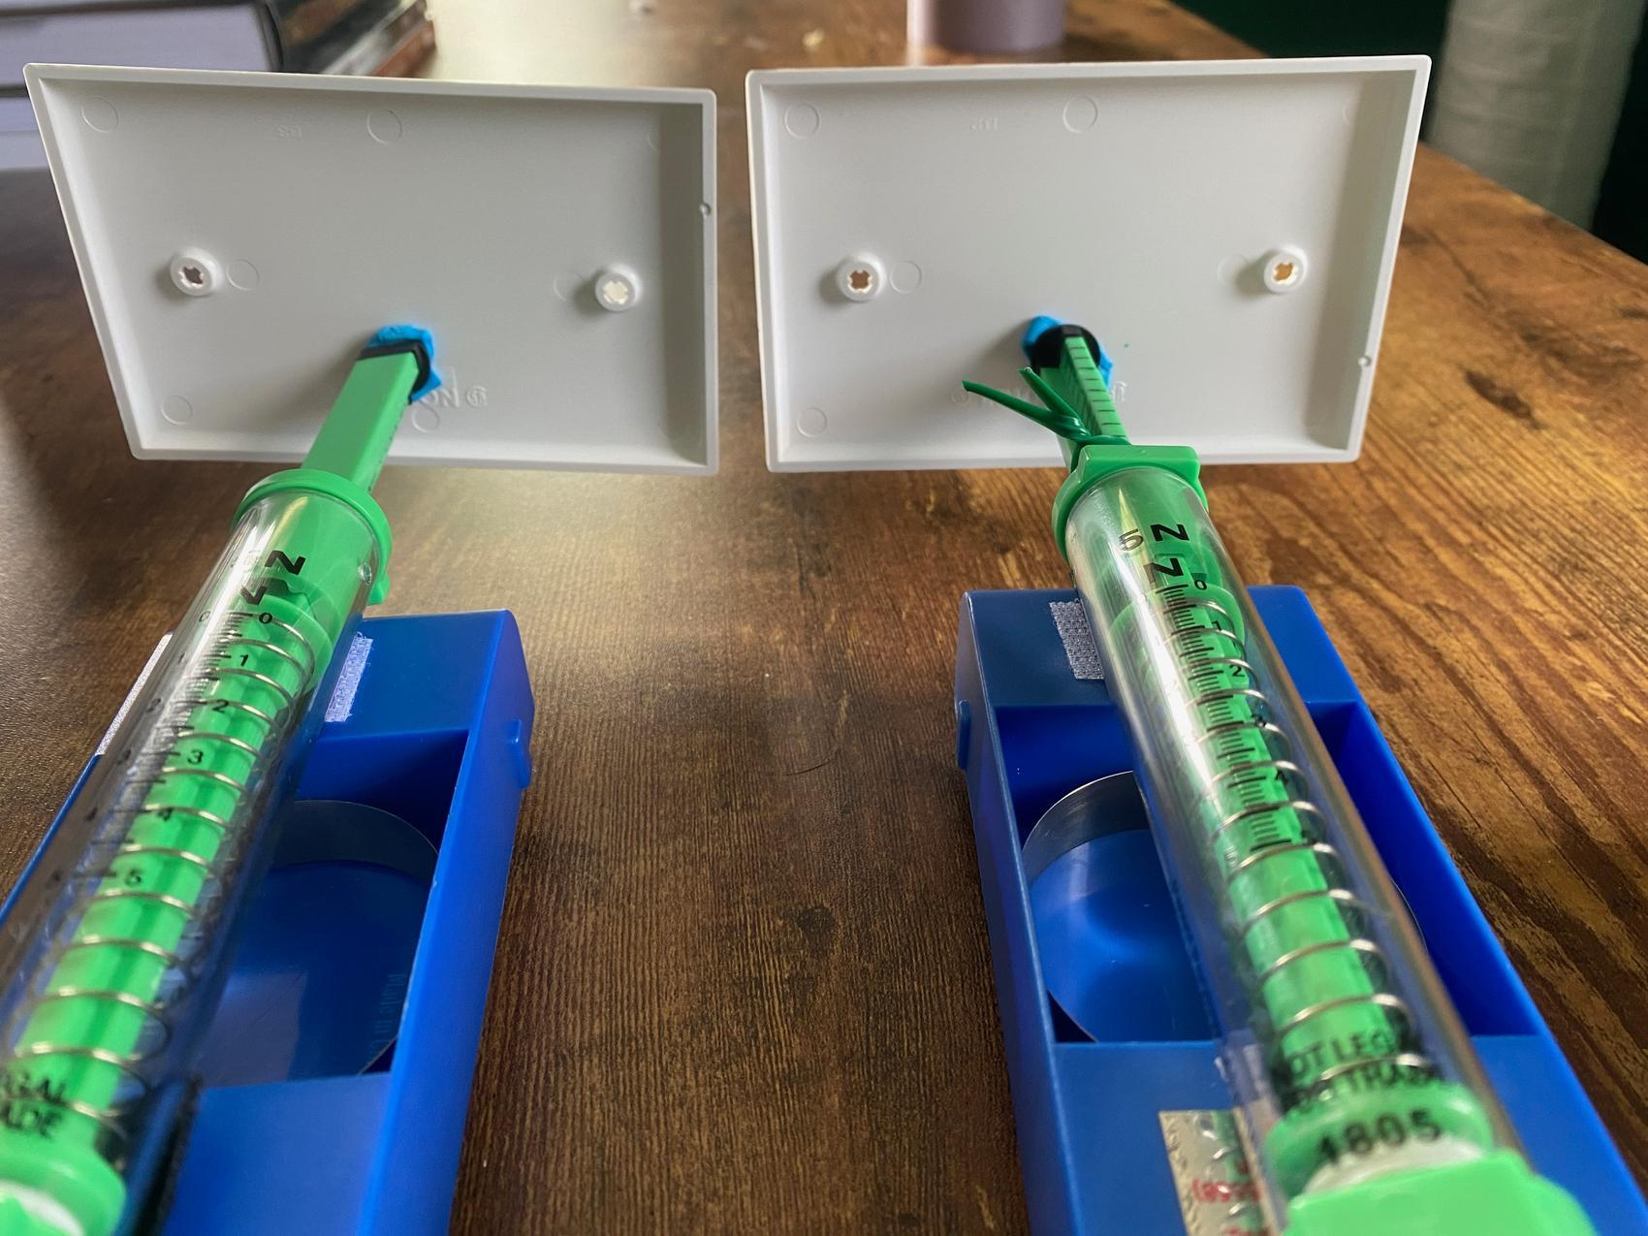
- Make sure that the two electrical plates touch flush when the carts are pushed together. | 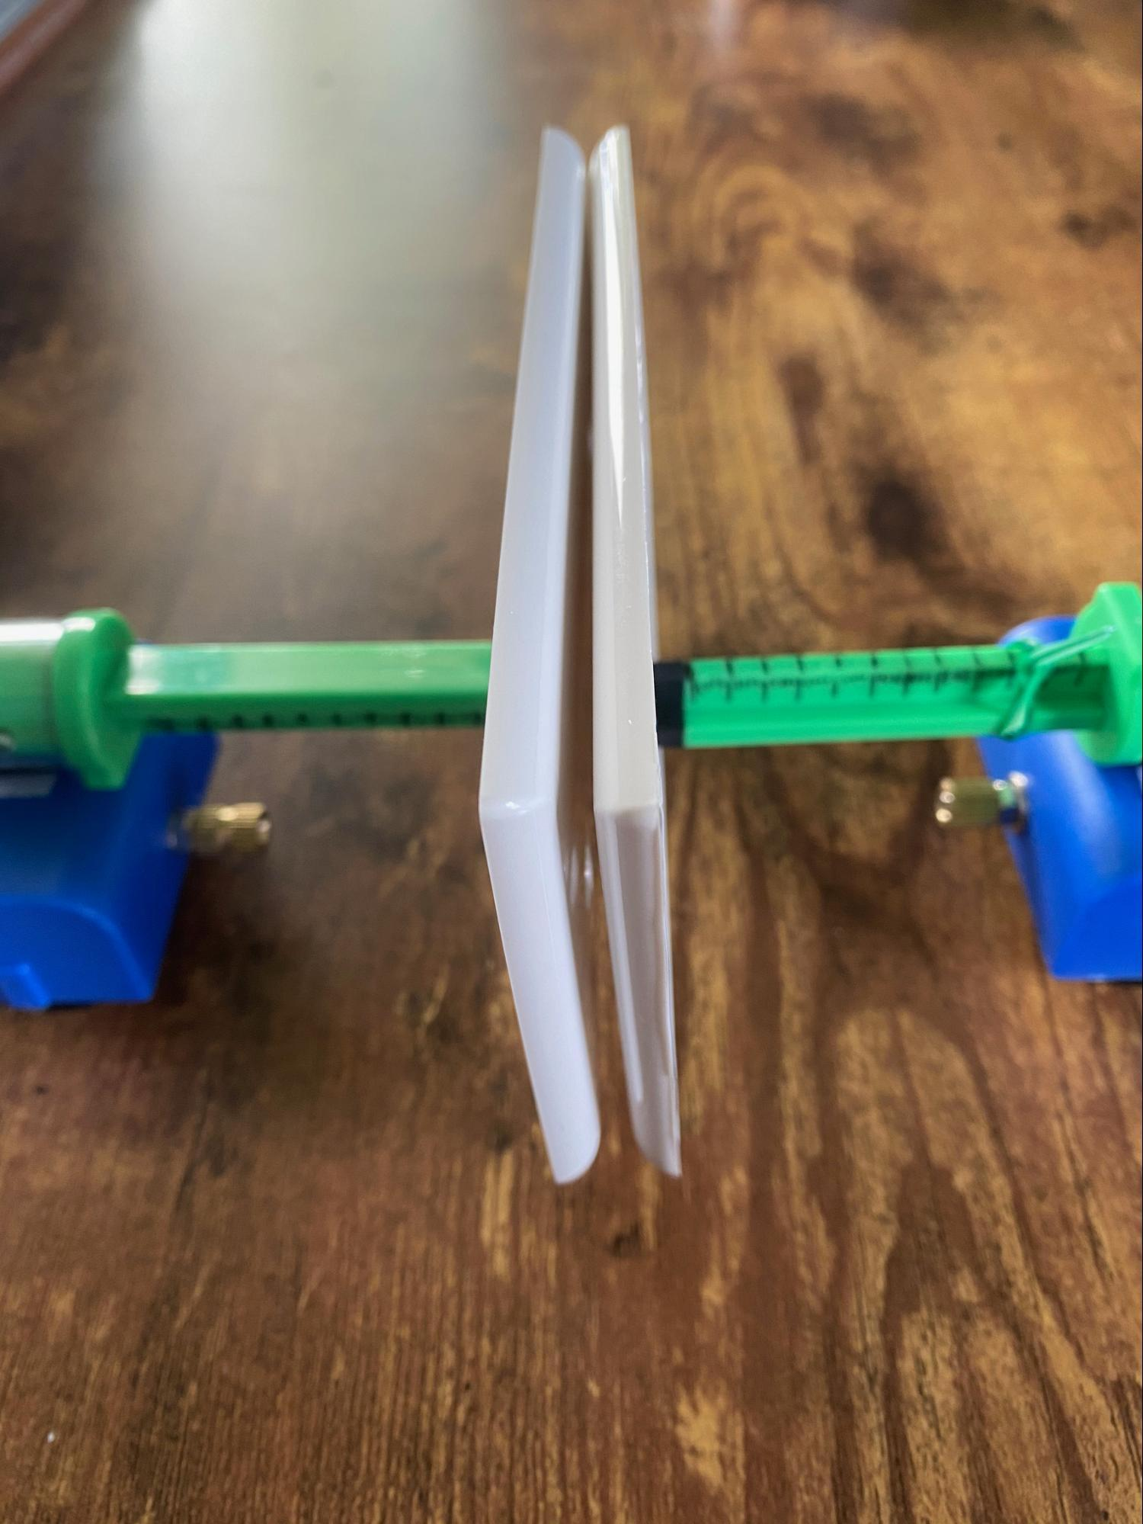
- Using duct tape, tape down one cart at the bottom of the ramp about 4 inches away from the brick with its plate facing up the ramp. | 